CLOSING THE GAP
  - STYLE GUIDE 2021


Contents
THE ARTIST 4
THE PARTNERSHIP 4
THE LOGO 6
VARIATIONS 7
CORRECT APPLICATIONS 8
Size 8
Positioning 8
Application 9
CO-BRANDING PARTNERSHIPS 10
INCORRECT APPLICATIONS 11
THE COLOURS 13
COLOUR PALETTE 13
USING THE PALETTE 13
Primary 13
Secondary 13
PALETTE 13
PRIMARY 13
SECONDARY 13
GRADIENTS 14
GRAPHIC ELEMENTS 15
MAIN ELEMENTS 15
Element 1 15
Element 2 15
Element 3 15
Element 4 16
EXAMPLES OF USE 17
Element 2 17
Element 3 17
Elements 2 and 3 17
TYPOGRAPHY 18
LOGO 18
PRIMARY FONT 18
Gotham Family 18
Gotham Book 18
Gotham Bold 18
Gotham Ultra & Light 18
SECONDARY 20
EXAMPLES 21
INCORRECT APPLICATIONS 23
DESIGN EXAMPLES 25
REPORT 25
Report 1 25
Report 2 26
Report 3 27
Report 4 27
A4 BRIEFING TEMPLATE 28
CAPS 29
ECOBAGS 30
A4 FACT SHEET 31
Option 1 31
Option 2 32
LECTERN SIGNS 32
MUGS 33
NOTEBOOKS 34
PENS 35
POLO SHIRT AND T-SHIRT 36
POWERPOINT TEMPLATE 36
PULL-UP BANNER 38

THE ARTIST
Lani Balzan is a proud Aboriginal woman from the Wiradjuri people of the three-river tribe. Her family originates from Mudgee but she grew up all over Australia, lived in many different towns, and now calls Illawarra home. Lani is a nationally recognised Aboriginal Artist having designed the artwork for the 2016 NAIDOC poster ‘Songlines’ and is well known for her jersey designs for the NRL Dragons. Her career started in 2014 when she designed a painting for the Cultural Season Art Competition. Now her artworks are respected around Australia and worldwide. Lani’s artworks are her passion and a way to share her culture which is very important to her.
https://www.lanibart.com.au/


THE PARTNERSHIP
In March 2019 the Commonwealth, all State and Territory governments, the Australian Local Government Association and the Coalition of Aboriginal and Torres Strait Islander Peak Organisations (the Coalition of Peaks) - representing over fifty Aboriginal and Torres Strait Islander community-controlled organisations - committed to fundamentally change the way they work together to accelerate improved life outcomes for Aboriginal and Torres Strait Islander people. The Closing the Gap Partnership Agreement (the Partnership Agreement) means that for the first time Aboriginal and Torres Strait Islander people, through their community-controlled peak organisations and members, are sharing decisions with governments on Closing the Gap, under a formal arrangement.
Following from this historic agreement, in July 2020, the parties committed to work together to overcome the inequality experienced by too many Aboriginal and Torres Strait Islander Australians and to achieve life outcomes equal to all Australians. The National Agreement on Closing the Gap (the National Agreement) is centred around four Priority Reforms that focus on changing the way that governments at all levels work with Aboriginal and Torres Strait Islander people. It also includes seventeen socio economic targets in key outcome areas, which reflect the desired result for Aboriginal and Torres Strait Islander people. The National Agreement was negotiated in genuine partnership between the Coalition of Peaks and all Australian Governments. The National Agreement includes commitments for shared decision-making as well as responsibility and shared accountability to Close the Gap.
For more information about the Partnership Agreement and the
National Agreement – https://www.closingthegap.gov.au/

THE LOGO
This logo represents government working together with Aboriginal and Torres Strait Islander people to close the gap. The red ochres represent Aboriginal people and the land, and the blue represents Torres Strait Islander people, our waters and government. The four rings are the four Priority Reforms which form the foundation for the 17 socio-economic targets represented by the inside dots


VARIATIONS
Main
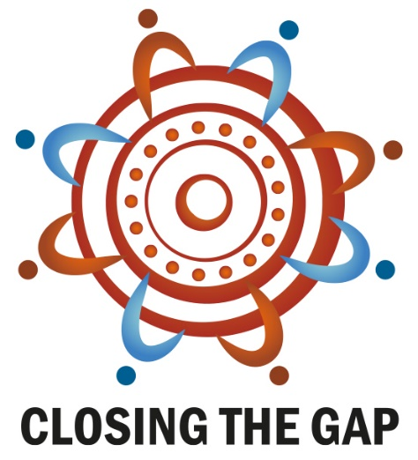
Mono

Reverse


CORRECT APPLICATIONS

Size
The minimum size of the logo must be 20mm (75 px) wide as measured across the diameter of the logo
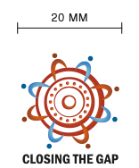

Positioning
The logo must be protected by an isolation zone of clear space at all times (this applies to every version and all applications).
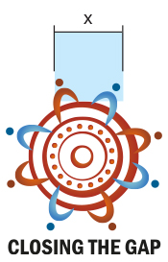
A minimum clear space, measuring the width of x must surround the logo on all sides
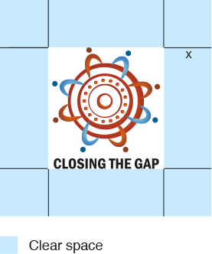

Application
The logo should always be placed on a white or light grey background
Logo on a white background

Logo on a light background

Logo on a dark background


CO-BRANDING PARTNERSHIPS
When co-branding the logo, please follow these guidelines.
Keep both logos the same weight, height and distance with the stroke in the middle.

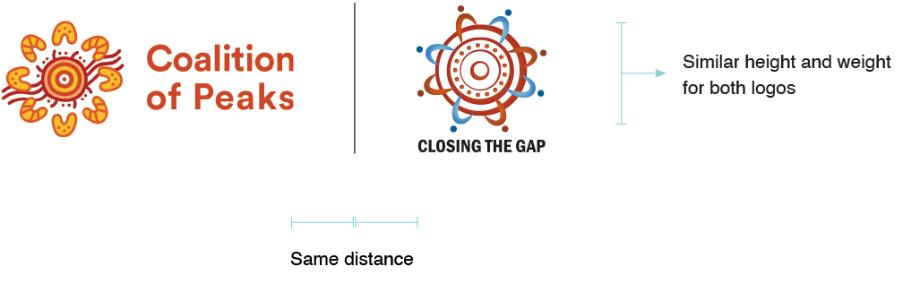

INCORRECT APPLICATIONS
Do not tilt the logo.

Do not enlarge or alter in proportion any part of the design.

Do not use the logo in a low contrast manner.


Do not distort the logo.

Do not change the colors of the logo.

Do not place the logo on an image.


THE COLOURS

COLOUR PALETTE
The red ochres represent Aboriginal people and the land, and the blue represents Torres Strait Islander people, our waters and government.

USING THE PALETTE

Primary
The primary colours are red ochre and blue.

Secondary
The secondary colours are part of the gradient mix in the logo and can be used to add flexibility to the design.

PALETTE


C4 M89 Y81 K30
R171 G48 B42
#AB2F2A

C75 M41 Y0 K0
R63 G132 B197
#3E84C5

SECONDARY


C2 M71 Y89 K22
R191 G88 B41
#BF5828

C0 M70 Y100 K0
R243 G112 B33
#F36F21

C1 M49 Y86 K0
R244 G149 B60
#F4953C

C44 M0 Y18 K0
R138 G210 B213
#89D2D

C0 M0 Y0 K15
R220 G221 B222
#DBDCDE

GRADIENTS
The gradients are an important part of the logo and should be used in preference to flat colours in any design. Only the gradients shown here may be used. Ensure the correct CMYK/RGB values are used.

Dark Red
C4 M89 Y81 K30
R171 G48 B42
#AB2F2A
Orange
C0 M70 Y100 K0
R243 G112 B33
#F36F21

Darker Orange
C2 M71 Y89 K22
R191 G88 B41
#BF5828
Orange
C0 M70 Y100 K0
R243 G112 B33
#F36F21

Blue
C75 M41 Y0 K0
R63 G132 B219
#3E84C5
Light Blue
C44 M0 Y18 K0
R138 G210 B213
#89D2D4

GRAPHIC ELEMENTS

MAIN ELEMENTS
The elements shown are part of the logo and can be applied to the design in association with the content.
They can be used as a full circle or part circle to accentuate the design.

Element 1
The Partnership represented by people symbols.


Element 2
4 Priority Reforms represented by the 4 circles.


Element 3
17 Socio-economic Targets represented by the 17 dots.
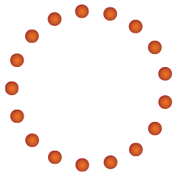

Element 4
4 Priority Reforms and17 Socio-Economic Targets.


EXAMPLES OF USE
Element 2 - In conjunction with headings

Element 3 - In conjunction with headings

Elements 2 and 3 - In conjunction with images



TYPOGRAPHY

LOGO
Franklin Gothic Demi Condensed Used only on the logo. Not to be used anywhere else
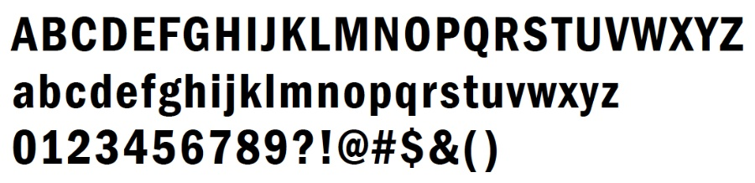

PRIMARY FONT

Gotham Family
Bold and Book should be most commonly used but you can also use Ultra and Light where necessary.

Gotham Book
Used on body copy and some sub-headlines.
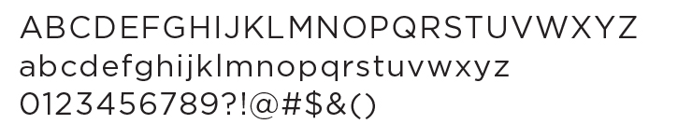

Gotham Bold
Used on headlines in all caps, content sub-headlines and some sub-headlines where required.
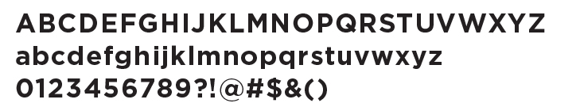

Gotham Ultra & Light
Used to differentiate important and/or unique information.
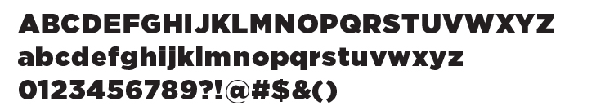
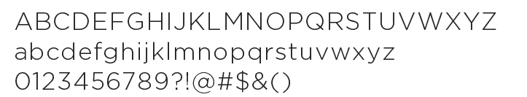

SECONDARY
Arial
The secondary typeface is ‘Arial’ and should be used when the primary typeface is not available. Arial is also more suited to digital applications.
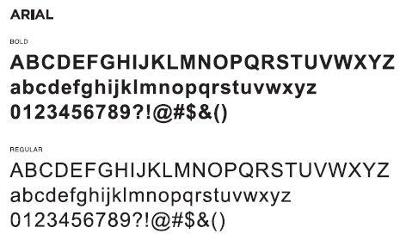

EXAMPLES
Typography is a pillar of our brand and should be used correctly. Always aim for contrast across all typographic hierarchies.
All type is to be set in Gotham.
Headline
Headlines are to be set in Gotham Bold and in high caps.
Sub-headline
Sub-headlines are to be set in high caps and Gotham Book.
Content sub-headline
Content sub-headlines are to be set in bold at the same text size as the body copy it sits with.
Body copy
Body copy is to be set in Gotham Book. At a minimum the text size is to be 9pt with 14pt leading and -7 tracking.
Important information
Important information can be styled in different ways to help differentiate it from other information. Using Ultra and Light are preferred.
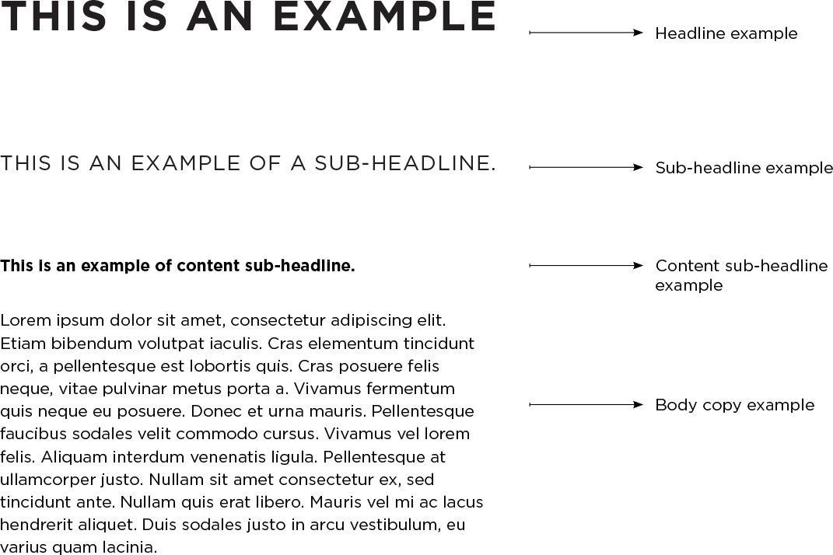

INCORRECT APPLICATIONS
Do not adjust kerning or tracking.
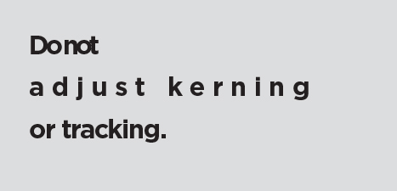
Do not recolor.

Do not make hierarchy levels the same weight.
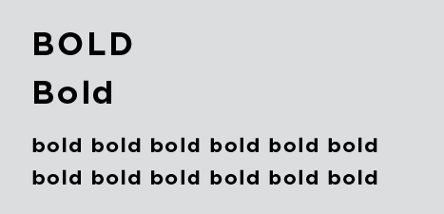
Do not make hierarchy levels the same size.

Do not use other typefaces.

Do not use lower cap for the headlines.


DESIGN EXAMPLES

REPORT

Report 1
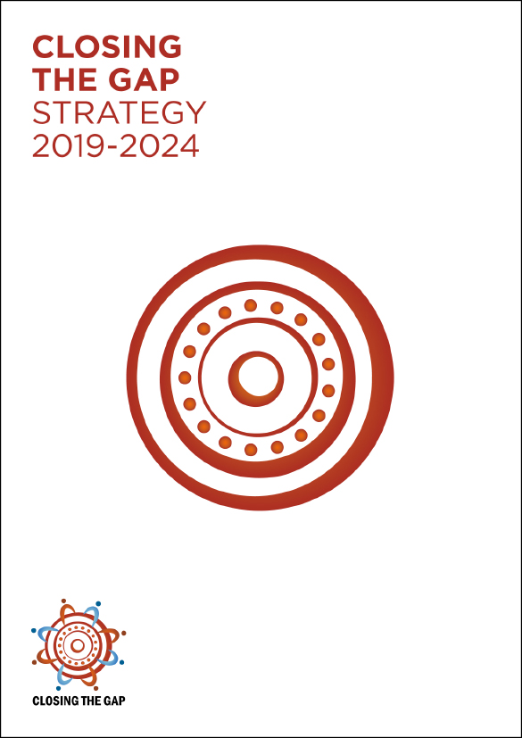

Report 2
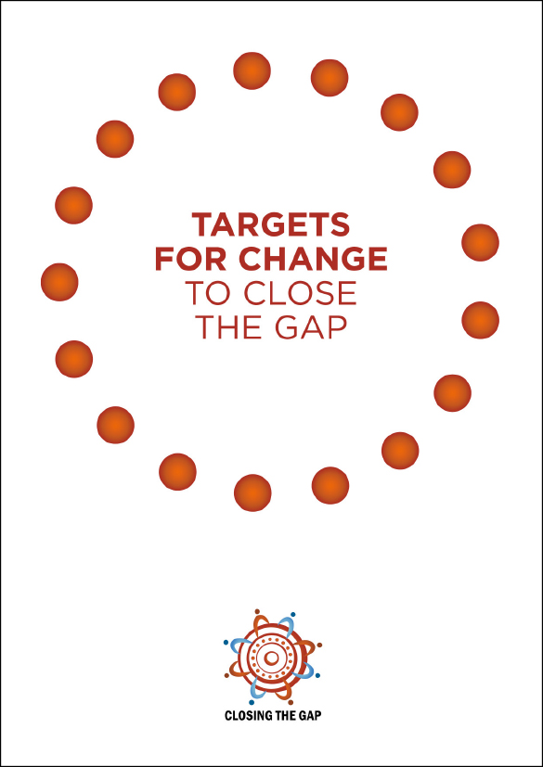

Report 3


Report 4
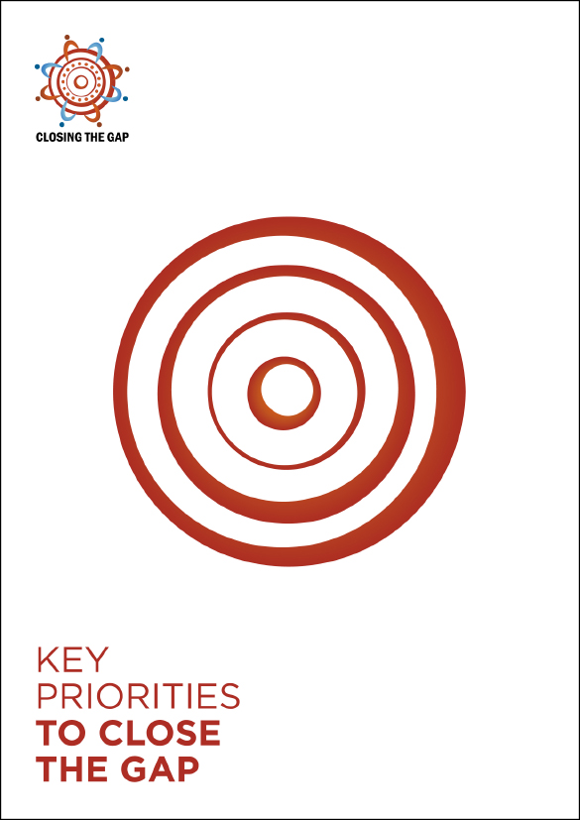

A4 BRIEFING TEMPLATE
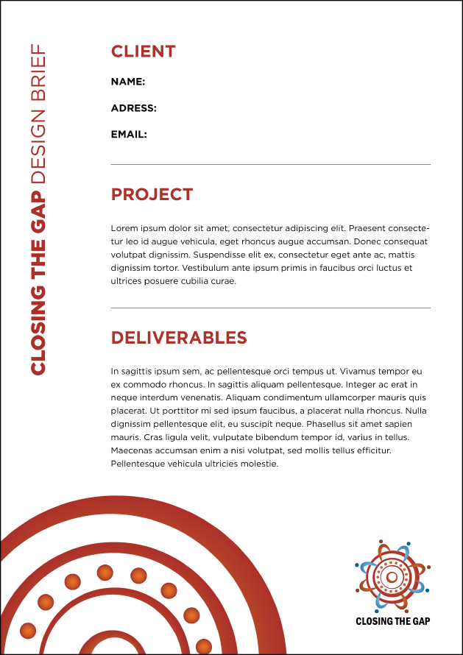

CAPS
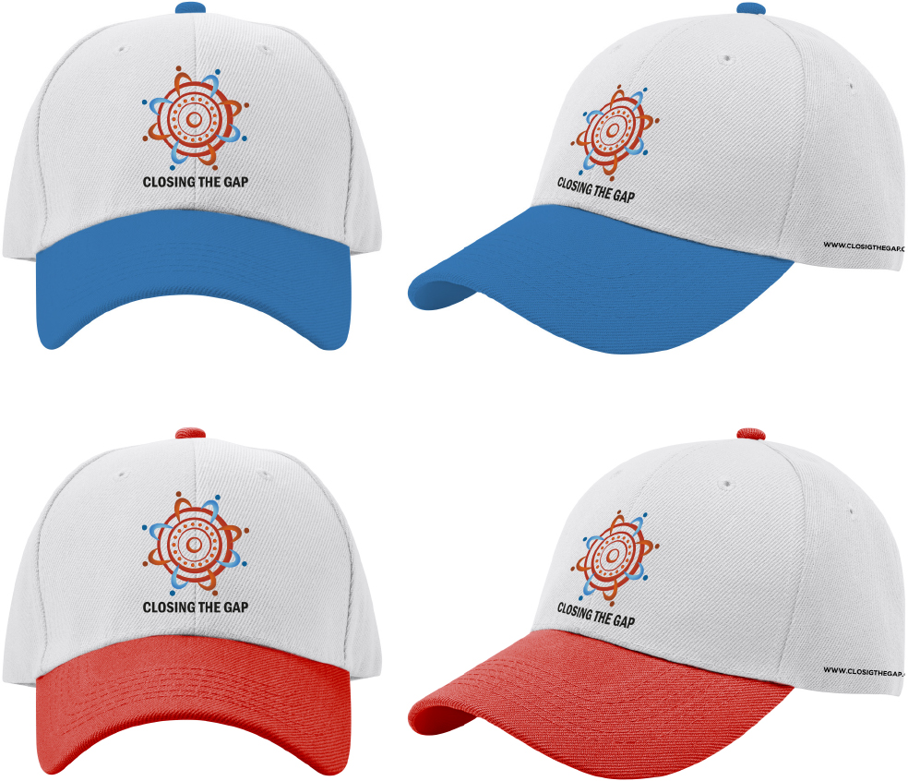

ECOBAGS
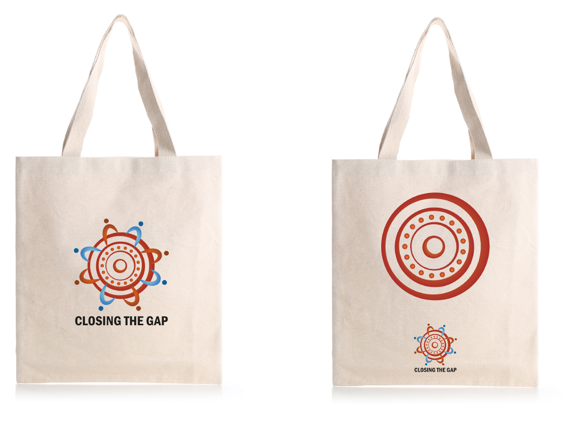

A4 FACT SHEET

Option 1
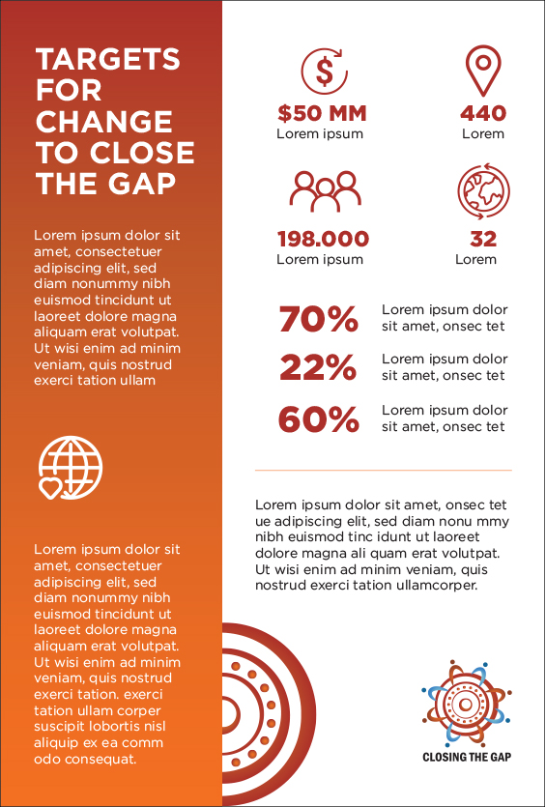

Option 2
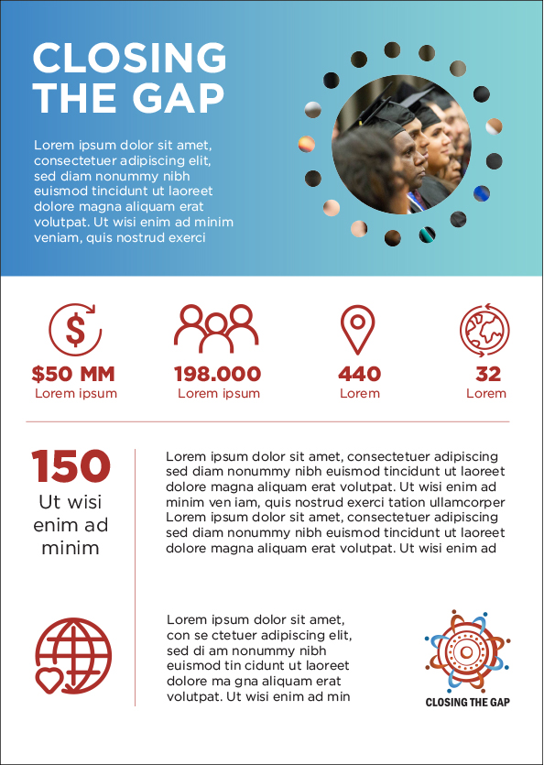

LECTERN SIGNS
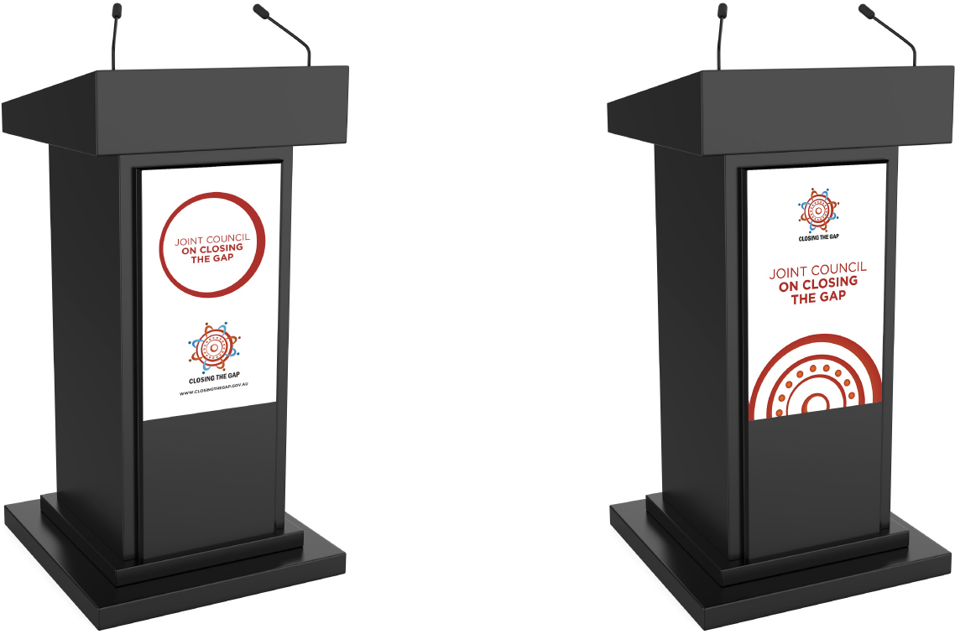

MUGS
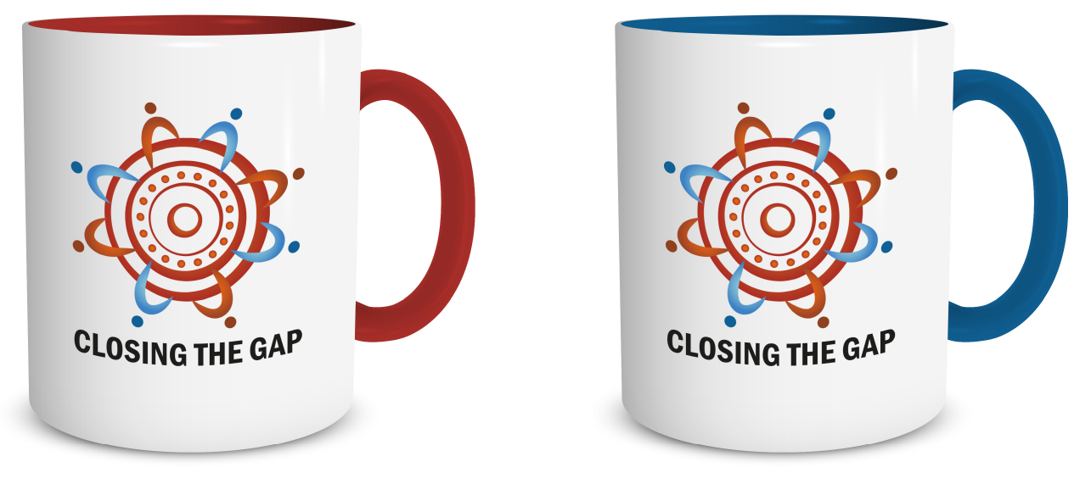

NOTEBOOKS

PENS
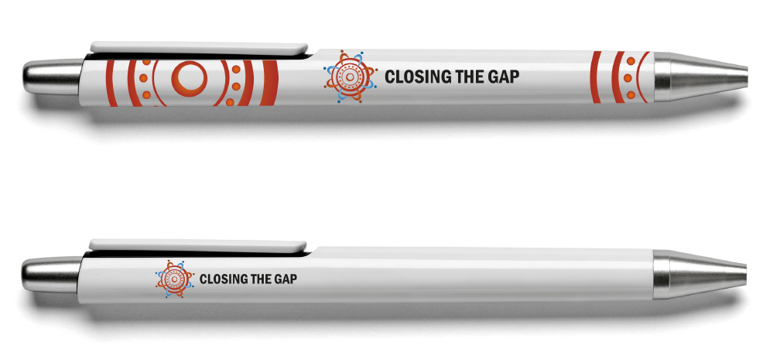

POLO SHIRT AND T-SHIRT
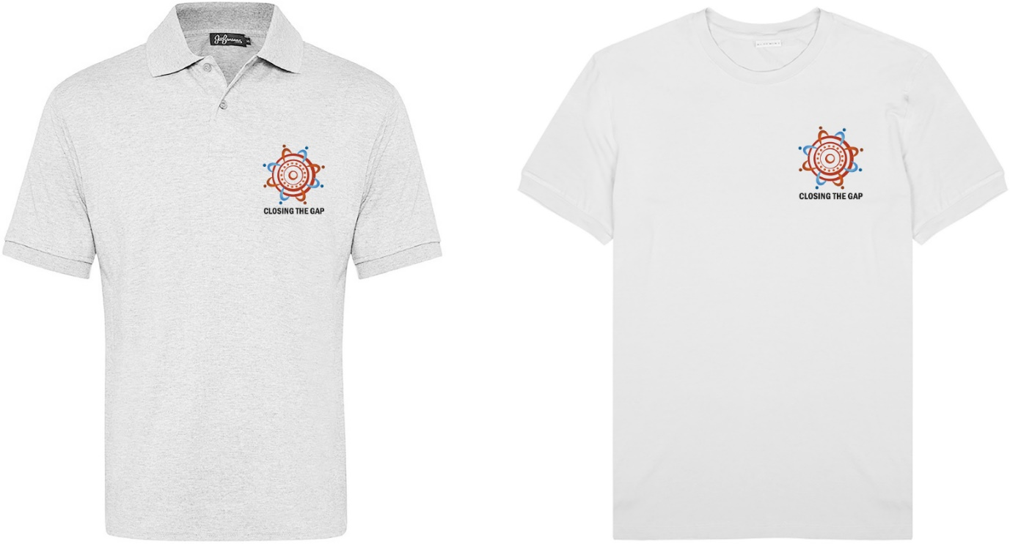

POWERPOINT TEMPLATE

PULL-UP BANNER
